*Impact of COVID-19 On Post-Covid Health of Patients*

Pranav Patil, Atharva Gurav, Sakshi Bhutada and Priyal Choudhary

***Abstract: -*****COVID-19 symptoms can sometimes persist for months. The virus can damage the lungs, heart and brain, which increases the risk of long-term health problems.**

**Most people who had coronavirus disease 2019 (COVID-19) recovered completely within a few weeks. But some people — even those who had mild versions of the disease — continue to experience symptoms after their initial recovery. The objective of this study is to assess the prevalence of health status and physical and mental health symptoms among individuals Post COVID**

1. INTRODUCTION

Some patients who have been infected with SARS-CoV-2, the virus that causes COVID-19, have new, recurring, or ongoing symptoms and clinical findings four or more weeks after infection, sometimes after initial symptom recovery. Post-COVID conditions can occur in patients who have had varying degrees of illness during acute infection, including those who had mild or asymptomatic infections. Medical and research communities are still learning about these post-acute symptoms and clinical findings.

We use post-COVID conditions as an umbrella term for the wide range of health consequences that are present four or more weeks after infection with SARS-CoV-2. The time frame of four or more weeks provides a rough approximation of effects that occur beyond the acute period, but the timeframe might change as we move ahead.

It can be difficult to distinguish symptoms caused by post-COVID conditions from symptoms that occur for other reasons. Patients experiencing the acute and post-acute effects of COVID-19, along with social isolation resulting from COVID-19 pandemic prevention measures, frequently suffer from symptoms of depression, anxiety, or mood changes. Alternative reasons for health problems need to be considered, such as other diagnoses, unmasking of pre-existing health conditions, or even SARS-CoV-2 reinfection.

Effects of COVID-19 illness or hospitalization can include tracheal stenosis from prolonged intubation, severe weakness, and deconditioning. Some of these effects are similar to those from hospitalization for other respiratory infections or other conditions. This category can also encompass post-intensive care syndrome (PICS), which

includes a range of health effects that remain after a critical illness. These effects can include severe weakness and post-traumatic stress disorder. Though the effects of hospitalization may not be unique to COVID-19 illness, they are considered post-COVID conditions if they occur after a SARS-CoV-2 infection and persist for four or more weeks.

1. RELATED WORK

In [1] The multivariable logistic regression analysis was performed based on age, sex, obesity, hypertension, etc. to determine the impact of heart failure. Through this research we came to know that patient with pre-existing heart disease are at higher risk compare to the patient having post covid heart disease[5]

In [2] This study shows the early stages of covid 19 outbreak from initial stages till the death or fully recovery of patient. This study states the different stages in covid 19, what are the symptoms ,which methods or treatments will be performed and medication based on person to person. Hypnotics is used cure the patients which are hypersensitive and be afraid of dying due to covid19.[6]

In [3] A considerable part of patients with COVID-19 had persistent symptoms even 4–5 months after COVID-19 diagnosis, and even patients with a mild-to-moderate disease suffered from persistent symptoms.

In [4] Certain patients with covid-19, particularly those with advanced age and hypertension, were in a critical condition on admission and progressed rapidly to death within two to three weeks from disease onset

SARS-Cov-2 infection can cause both pulmonary and systemic inflammation, leading to multi-organ dysfunction in high-risk populations

In addition to acute respiratory distress syndrome and type I respiratory failure, acute cardiac injury and heart failure may also contribute to the critical illness state associated with high mortality.

In [5] showed features of myocardial abnormalities in patients, in whom the cardiac complications had not previously been diagnosed.

In [6] This report describes a COVID-19 pneumonia cohort of 179 patients who were hospitalised to Wuhan Pulmonary Hospital. It noted the top five common symptoms included fever ,dry cough ,dyspnoea ,fatigue and sputum production on admission among the total population Except for dyspnoea, fatigue, sputum production and headache, which were more frequently present in the deceased group than in the survivor group other kinds of symptoms were similar in the two groups. there was no difference in heart rate.

In [7] This Study shows how to identify   COVID-19 malignant progression for reducing the patient stratification uncertainty, optimizing the diagnosis and treatment, increasing the efficiency of medical resource allocation, improving the emergency response capacity of the medical system, and ultimately decreasing the mortality.

In [8] By this study we determined the association of cardiovascular metabolic diseases with the development of COVID-19 and we found that Patients with previous cardiovascular metabolic diseases may face a greater risk of developing into the severe condition and the comorbidities can also greatly affect the prognosis of the COVID-19. On the other hand, COVID-19 can, in turn, aggravate the damage to the heart.

1. DATASET AND FEATURES

DATA VISUALIZATION

1.USING TABLEAU :

Fig 1. The severity of fatigue.

.

Fig 2. Development of any new Chest condition

Fig 3. Major Symptoms for covid19

Fig 4. Effect of drinking alcohol on COVID 19

Fig 5. Post Covid Fatigue Based on procurement Period for covid

Fig 6. Side Effect of Medicines

Fig 7. After Effects on Body

2. USING ORANGE

Fig 8. Data Table

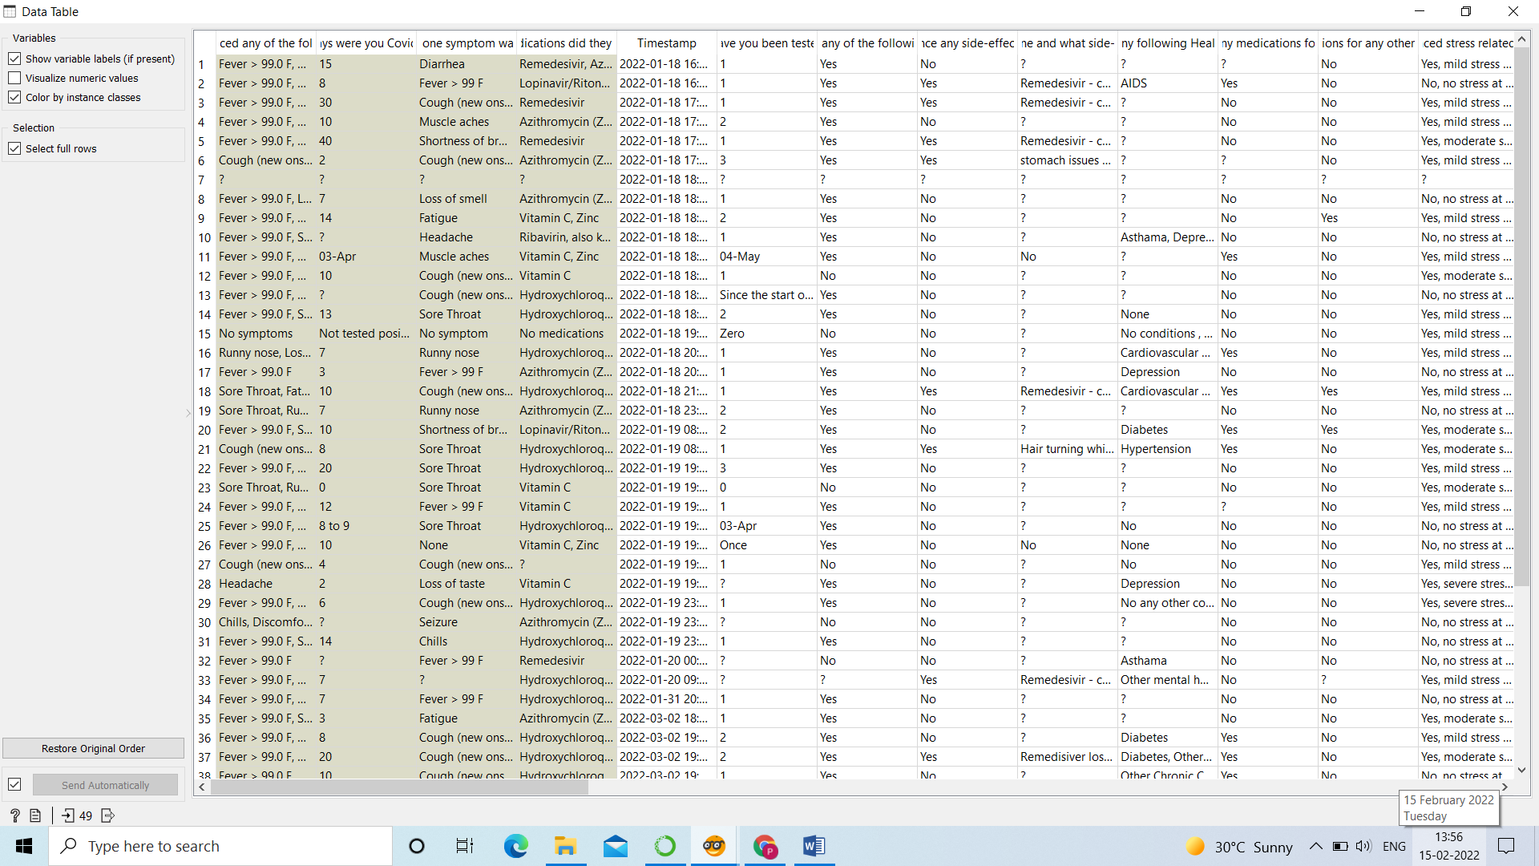

Fig 9. Dashboard

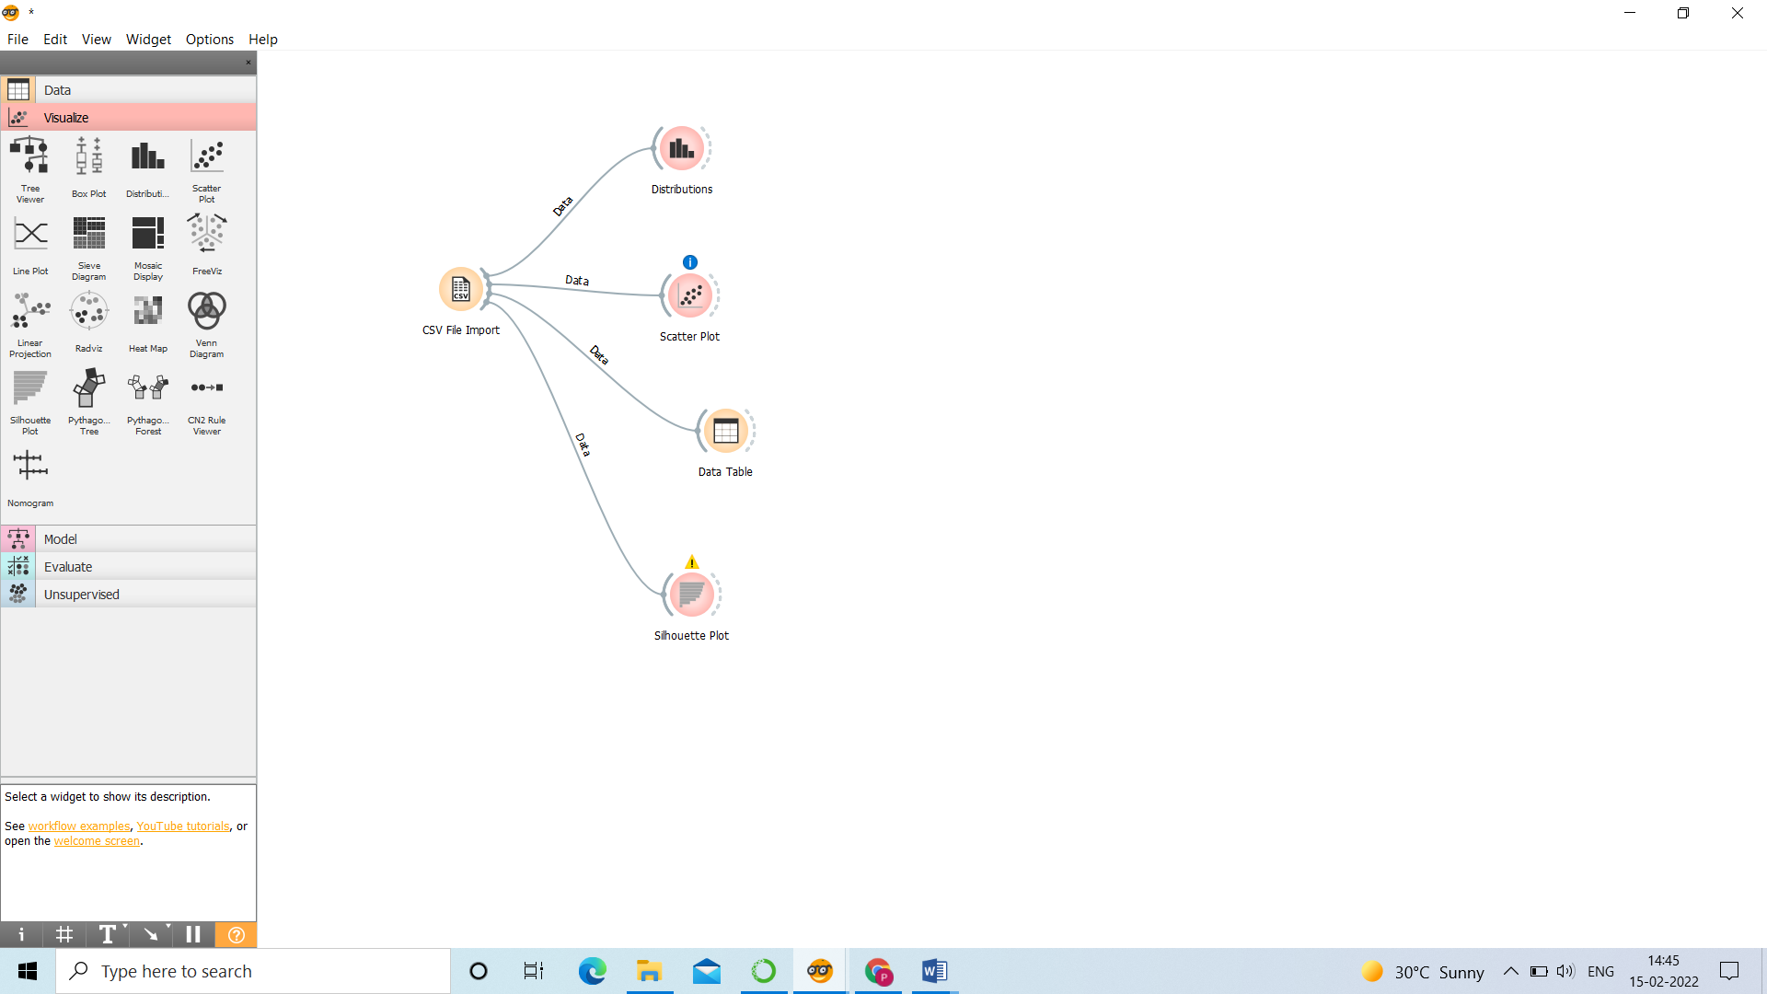

Fig 10. Did you experience any side effects of medicines?

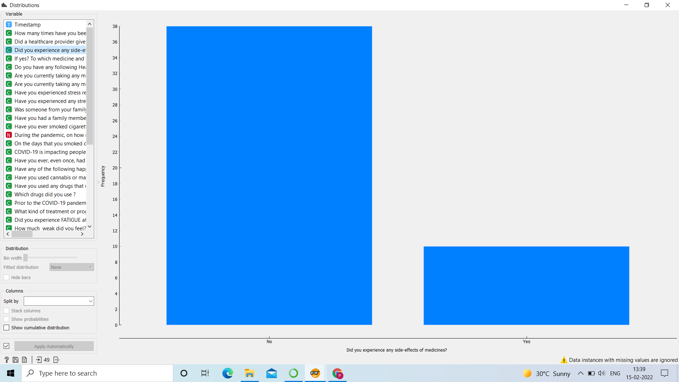

Fig 11. Duration of weakness after pandemic.

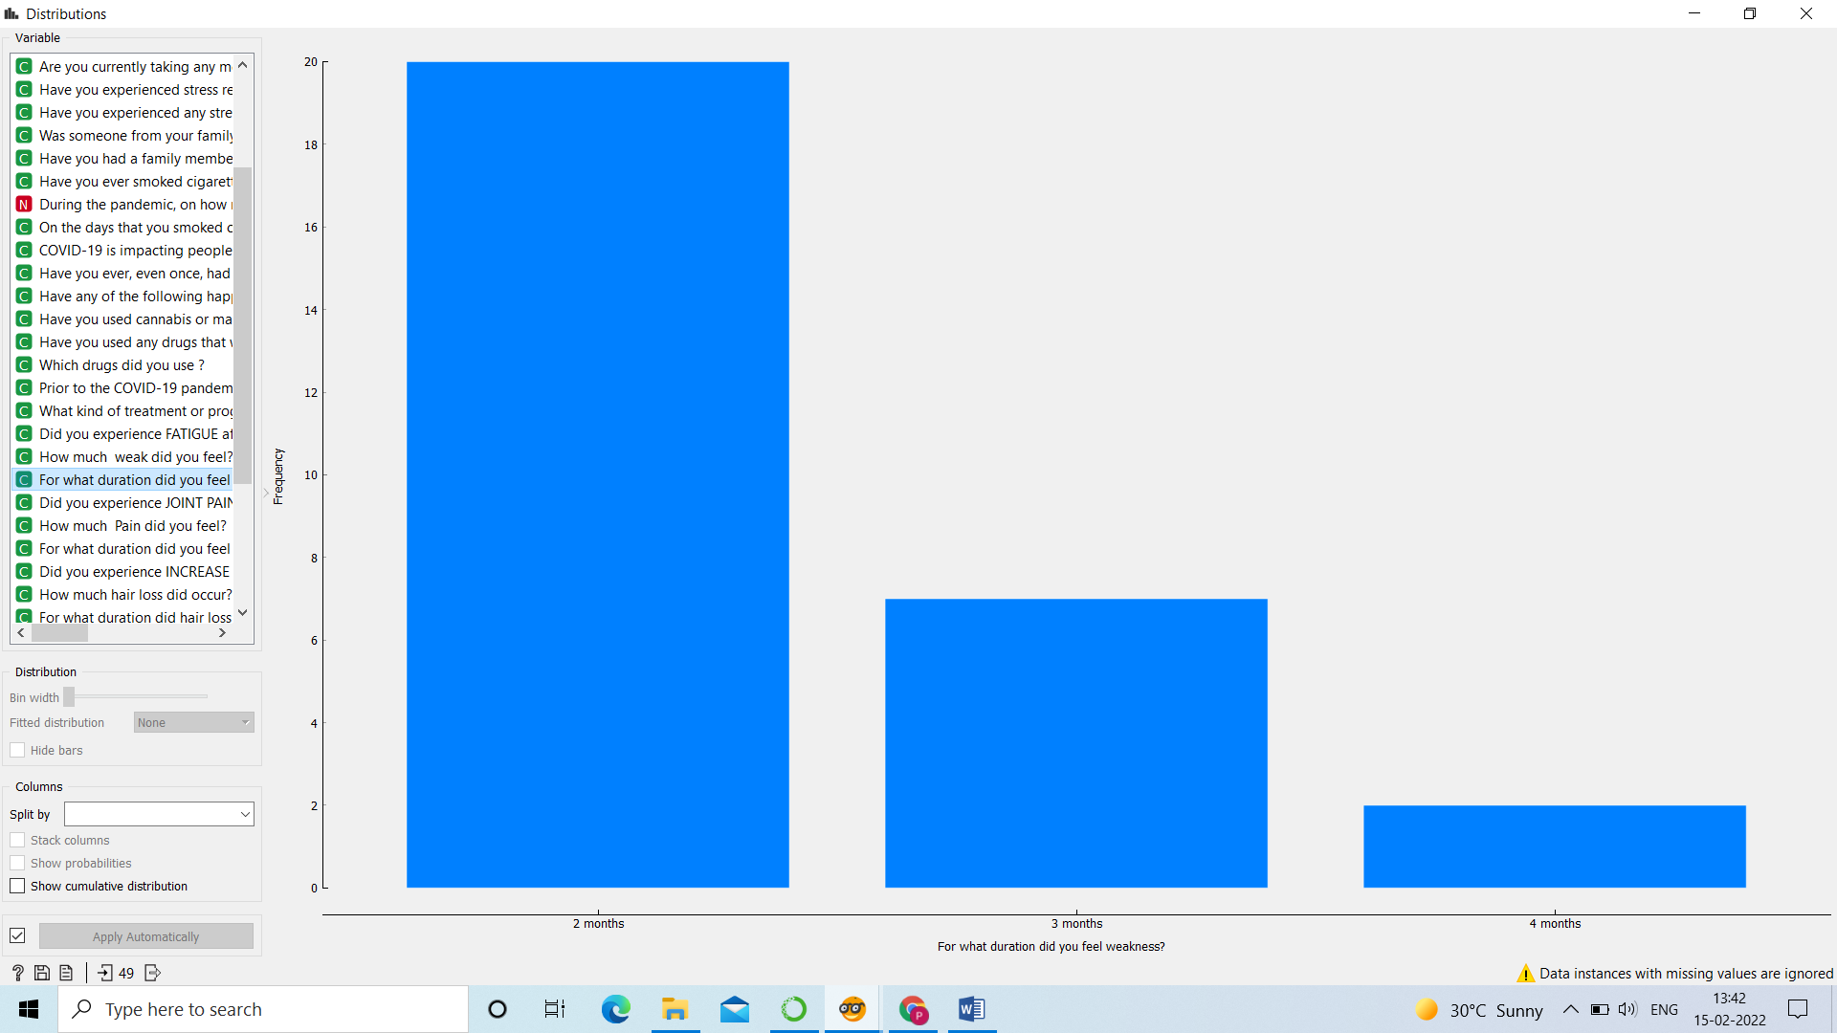

Fig 12. Did you experienced chest pain after testing negative?

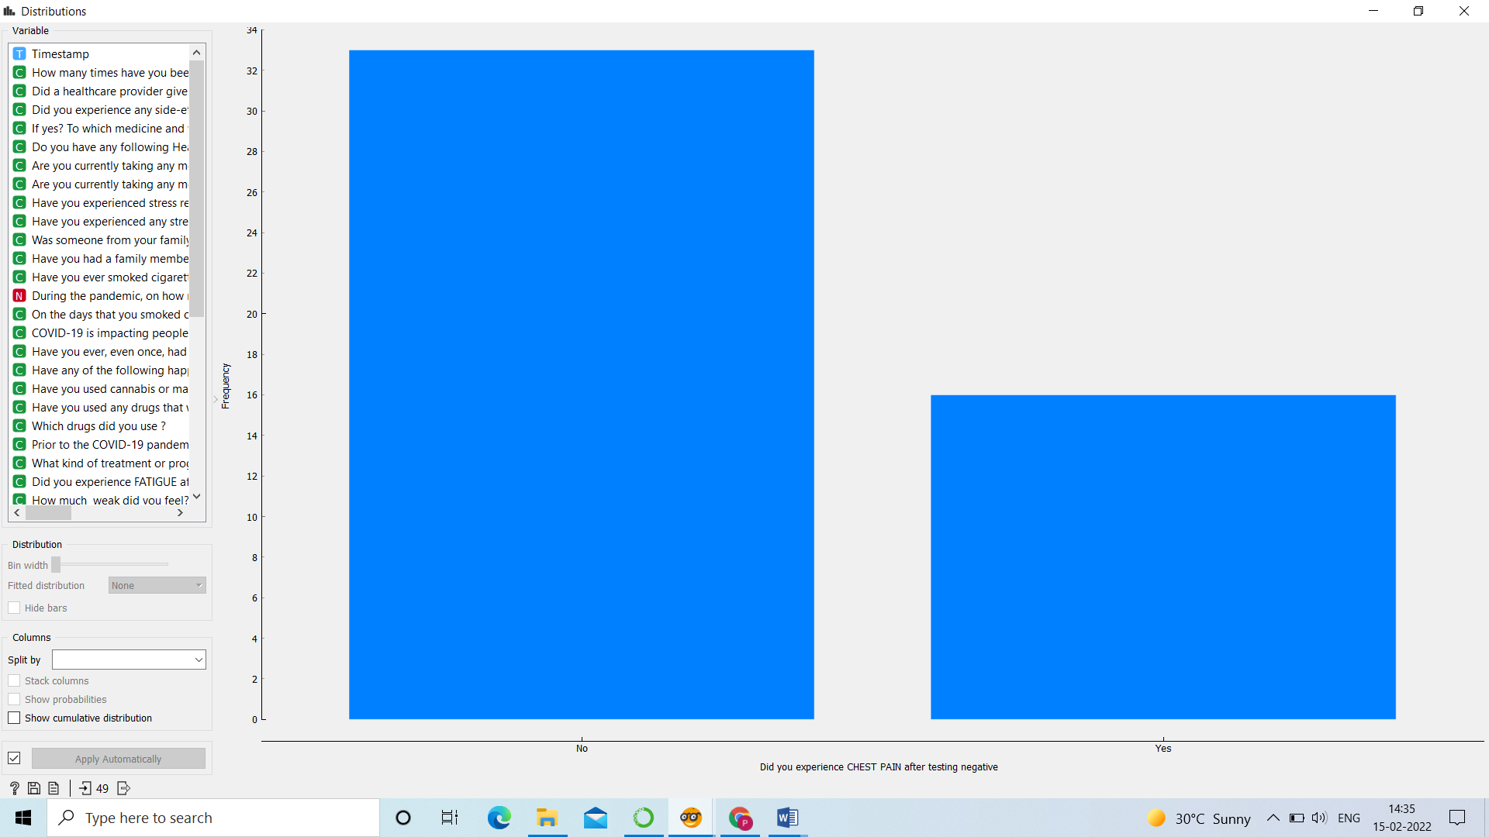

Fig 13. During pandemic how many days did you smoke part or all of a cigarette?(Scatter Plot)

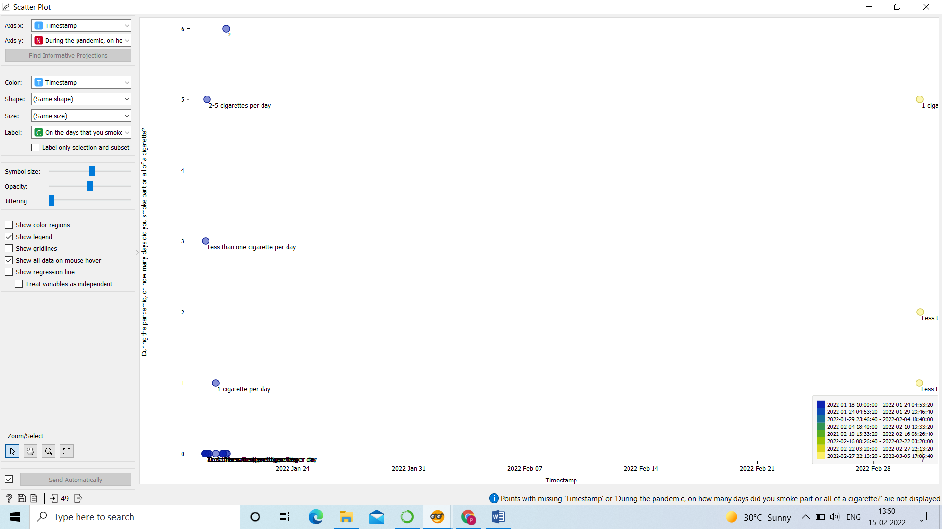

Fig 14. Health Conditions Suffered During Pandemic.(Silhouette Plot)

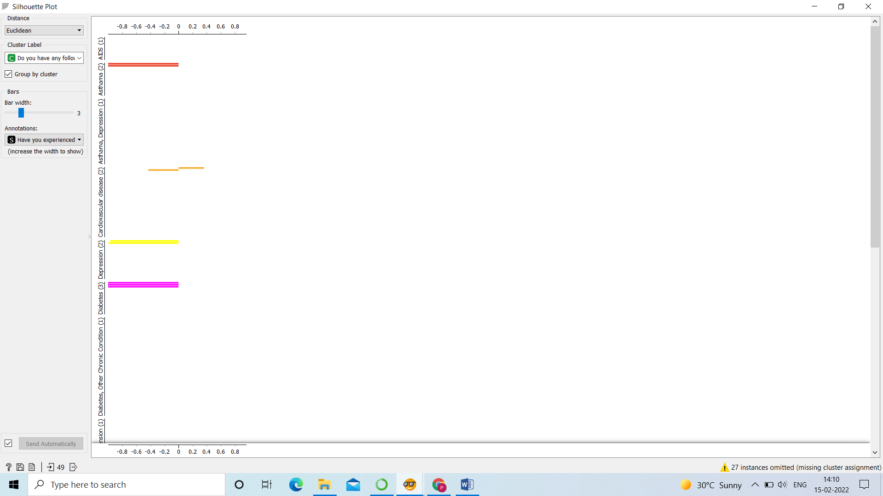

1. EXPERIMENTS/RESULTS/DISCUSSION

1. Stochastic Gradient Descent Classifier

This estimator implements regularized linear models with stochastic gradient descent (SGD) learning: the gradient of the loss is estimated each sample at a time and the model is updated along the way with a decreasing strength schedule (aka learning rate). SGD allows minibatch (online/out-of-core) learning via the partial fit method. For best results using the default learning rate schedule, the data should have zero mean and unit variance. This implementation works with data represented as dense or sparse arrays of floating-point values for the features. The model it fits can be controlled with the loss parameter; by default, it fits a linear support vector machine (SVM). The regularize is a penalty added to the loss function that shrinks model parameters towards the zero-vector using either the squared Euclidean norm L2 or the absolute norm L1 or a combination of both (Elastic Net). If the parameter update crosses the 0.0 value because of the regularize, the update is truncated to 0.0 to allow for learning sparse models and achieve online feature selection.

2. Support vector Machine

Support vector machines (SVMs) are a set of supervised learning methods used for classification, regression and outliers’ detection. The advantages of support vector machines are:

Effective in high dimensional spaces.

Still effective in cases where number of dimensions is greater than the number of samples.

Uses a subset of training points in the decision function (called support vectors), so it is also memory efficient.

Versatile: different Kernel functions can be specified for the decision function. Common kernels are provided, but it is also possible to specify custom kernels.

The disadvantages of support vector machines include:

If the number of features is much greater than the number of samples, avoid over-fitting in choosing Kernel functions and regularization term is crucial.

SVMs do not directly provide probability estimates, these are calculated using an expensive five-fold cross-validation.

3. Random Forest Classifier

A random forest is a meta estimator that fits a number of decision tree classifiers on various sub-samples of the dataset and uses averaging to improve the predictive accuracy and control over-fitting. The sub-sample size is controlled with the max_samples parameter if bootstrap=True (default), otherwise the whole dataset is used to build each tree.

4. Decision Tree Classifier

Decision Trees (DTs) are a non-parametric supervised learning method used for classification and regression. The goal is to create a model that predicts the value of a target variable by learning simple decision rules inferred from the data features. A tree can be seen as a piecewise constant approximation.**Graphical user interface, application
**

1. EXPERIMENTS/RESULTS/DISCUSSION

In Fig 1 from the above chart, we can say that the patient who are recovered from covid 19 can face the problem of fatigue for some duration of time with respect to our observation we can say that

1. 12 out of 49 patient were immune to fatigue
2. 2 out of 49 patients suffered minimal fatigue
3. 15 out of 49 patients suffered normal fatigue
4. 5 out of 49 patient suffered maximum fatigue

Buy this we can say that most of the people recovered from covid are suffering normal fatigue while doing their day-to-day work.

In Fig 2 From the above chart, we can say that the number of patients develop any chest condition after procurement from covid is higher than the other aspects. It is showing that the patient who acquired shortness of breath after COVID-19 is just one patient out of 49 patients. It is also showing that after recovery from COVID-19 most of the patients change their behaviour and become short tempered sometimes.

|  |  |  |  |
| --- | --- | --- | --- |
| Algorithm Name | Score | Mean Absolute Error | Mean Squared Error |
| SDGClassifier | 0.7 | 0.5 | 1.1 |
| SVM | 0.9 | 0.1 | 0.1 |
| RandomForest | 0.8 | 0.4 | 1.0 |

In Fig 3 is an area graph which shows that which was the major symptom of the patient during COVID-19 by this weekend conclude that most of the patients we're having seizure and runny nose. Slightly less than that patient was suffering fatigue and very small fraction of the patient were having sore throat.

In Fig 4 is an area graph which shows how many patients have develop any kind of chest condition based on their alcohol connection habit. We can clearly see that out of 49 patients 19 patients were clean and 5 patients were drinking but haven't got any test condition. Out of the remaining patients most of them world drinking on regular basis and develop a mild pain in the chest and some of them remained not drinking but developed slight chest discomfort for minimum span of time.

In Fig 5 This area graph shows that for how much day’s patients were covid positive or how many days it took them to recover from covid whether respect to their fatigue level after being tested negative. The results are out of 49 patients it took 2 patients 10 days of time for recovery, and they suffered normal fatigue and very much fatigue as a post covid condition. The least time span for which a patient was positive is between 3 to 4 days and he suffered minimal fatigue after recovery.

In Fig 6 graph shows that were there any side effects of medicines on the patient after recovery from covid. As we can see most of the people were recovered successfully but haven't got any post condition or side effect. But that one person and 34 who got some side effects due to remdesivir. This data is based on 49 patients and only one person got side effects it means that 2% of the people who are recovering from covid are suffering from this side effect.

In Fig 7 This graph shows the count of patient who developed any aftereffects of COVID-19 on their body which consist of chest pain, swollenness, brittle teeth, fatigue, increase in hair loss and joint pain. It is observed that 15 amongst the 49 were clean and haven't developed any aftereffects. Whereas in every category there are 1-3 members who developed a single or multiple aftereffects.

Predicting Chest Pain

|  |  |  |  |
| --- | --- | --- | --- |
| Algorithm Name | Score | Mean Absolute Error | Mean Squared Error |
| SDGClassifier | 0.7333 | 0.2666 | 0.2666 |
| SVM | 0.9333 | 0.0666 | 0.0666 |
| RandomForest | 0.8 | 0.2 | 0.2 |

Predicting Chest Pain Sevierity

Predicting Fatigue

|  |  |  |  |
| --- | --- | --- | --- |
| Algorithm Name | Score | Mean Absolute Error | Mean Squared Error |
| SDGClassifier | 0.4666 | 0.5333 | 0.5333 |
| SVM | 1.0 | 0.0 | 0.0 |
| RandomFores | 0.8666 | 0.133 | 0.133 |

1. CONCLUSION/FUTURE WORK

From the results we got, we could analyse that smoking has a major role in the covid condition of patients getting severe. This was based on few models that we trained. The second major reason we could find was the stress and anxiety in the people due to the surrounding and other personal reasons. A lot of them also mentioned that this can be the only reason for patients not recovering faster. On the contrary of what we expected medications didn’t play a major role in worsening covid patients health. Still the side effects of Remdesivir cannot be ignored. Many of the doctors used remdesivir which resulted in near about 2% of the patients facing side effects. A large fraction of patients used normal medicines to recover but haven’t got any side effects of medicines. Like chest pain we can predict other post conditions as joint pain, brittle teeth, body sallowness, etc. If you are recovered from covid, there is a major chance that you will feel fatigue for some time in future. In the prediction algorithms, Decision Tree Classifier, even though giving good accuracy score, is performing the worst because it is unable to find feature importance for most of the columns in the dataset. Thus, we can conclude that Random Forest Classifier is ideal classifier for predicting post-covid health of patients. It gave good accuracy scores consistently and logical feature importance for most of the cases taken into consideration.

1. REFERENCES

[1] https://scikit-learn.org/stable/modules/generated/sklearn.linear_model.SGDClassifier.html

[2] https://scikit-learn.org/stable/modules/svm.html

[3] https://scikit-learn.org/stable/modules/generated/sklearn.ensemble.RandomForestClassifier.html

[4] https://scikit-learn.org/stable/modules/tree.html

[5] Jesus Alvarez-Garcia, Samuel Lee, Arjun Gupta, Matthew Cagliostro, Aditya A. Joshi, Mercedes Rivas-Lasarte, Johanna Contreras, Sumeet S. Mitter, Gina LaRocca, Pilar Tlachi, Danielle Brunjes, Benjamin S. Glicksberg, Matthew A. Levin, Girish Nadkarni, Zahi Fayad, Valentin Fuster, Donna Mancini, Anuradha Lala, Prognostic Impact of Prior Heart Failure in Patients Hospitalized With COVID-19, Journal of the American College of Cardiology,

Volume 76, Issue 20,2020,

Pages 2334-2348,

ISSN 0735-1097,

https://doi.org/10.1016/j.jacc.2020.09.549.

**[6]** Risk Factors Associated with Clinical Outcomes in 323 COVID-19 Patients in Wuhan, ChinaLing Hu, Shaoqiu Chen, Yuanyuan Fu, Zitong Gao, Hui Long, Hong-wei Ren, Yi Zuo, Huan Li, Jie Wang, Qing-bang Xu, Wen-xiong Yu, Jia Liu, Chen Shao, Jun-jie Hao, Chuan-zhen Wang, Yao Ma, Zhanwei Wang, Richard Yanagihara, Jian-ming Wang, Youping Deng

# doi: https://doi.org/10.1101/2020.03.25.20037721

# **[7]** Post-COVID syndrome: A single-center questionnaire study on 1007 participants recovered from COVID-19

# [Bircan Kayaaslan](https://onlinelibrary.wiley.com/action/doSearch?ContribAuthorRaw=Kayaaslan%2C+Bircan),[Fatma Eser](https://onlinelibrary.wiley.com/action/doSearch?ContribAuthorRaw=Eser%2C+Fatma),[Ayse K. Kalem](https://onlinelibrary.wiley.com/action/doSearch?ContribAuthorRaw=Kalem%2C+Ayse+K),[Gamze Kaya](https://onlinelibrary.wiley.com/action/doSearch?ContribAuthorRaw=Kaya%2C+Gamze),[Betul Kaplan](https://onlinelibrary.wiley.com/action/doSearch?ContribAuthorRaw=Kaplan%2C+Betul),[Duygu Kacar](https://onlinelibrary.wiley.com/action/doSearch?ContribAuthorRaw=Kacar%2C+Duygu),[Imran Hasanoglu](https://onlinelibrary.wiley.com/action/doSearch?ContribAuthorRaw=Hasanoglu%2C+Imran),[Belgin Coskun](https://onlinelibrary.wiley.com/action/doSearch?ContribAuthorRaw=Coskun%2C+Belgin),[Rahmet Guner](https://onlinelibrary.wiley.com/action/doSearch?ContribAuthorRaw=Guner%2C+Rahmet)

# First published: 13 July 2021

https://doi.org/10.1002/jmv.27198

# **[8]** Clinical characteristics of 113 deceased patients with coronavirus disease 2019: retrospective study

*BMJ* 2020; 368 doi: https://doi.org/10.1136/bmj.m1091 (Published 26 March 2020)

**[9]** Post-COVID-19 heart syndrome Aleksandra Gasecka, Michał Pruc, Katarzyna Kukula, Natasza Gilis-Malinowska, Krzysztof J. Filipiak, Milosz J. Jaguszewski, Lukasz Szarpak

# **[10]** Predictors of mortality for patients with COVID-19 pneumonia caused by SARS-CoV-2: a prospective cohort study

# Rong-Hui Du, Li-Rong Liang, Cheng-Qing Yang, Wen Wang, Tan-Ze Cao, Ming Li, Guang-Yun Guo, Juan Du, Chun-Lan Zheng, Qi Zhu, Ming Hu, Xu-Yan Li, Peng Peng, Huan-Zhong Shi

European Respiratory Journal 2020 55: 2000524; DOI: 10.1183/13993003.00524-2020

# **[11]** Deep learning for predicting COVID-19 malignant progression

Cong Fang, Song Bai, Qianlan Chen, Yu Zhou, Liming Xia, Lixin Qin, Shi Gong, Xudong Xie, Chunhua Zhou, Dandan Tu, Changzheng Zhang, Xiaowu Liu, Weiwei Chen, Xiang Bai, Philip H.S. Torr

doi: https://doi.org/10.1101/2020.03.20.20037325

**[12]** Li, B., Yang, J., Zhao, F. *et al.* Prevalence and impact of cardiovascular metabolic diseases on COVID-19 in China. *Clin Res Cardiol* **109,**531–538 (2020). https://doi.org/10.1007/s00392-020-01626-9